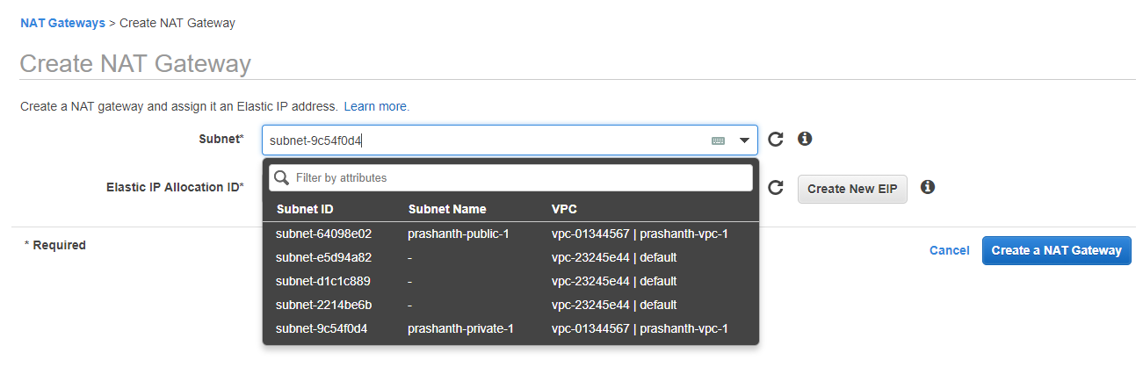

- NAT gateway always it has to be in public network.

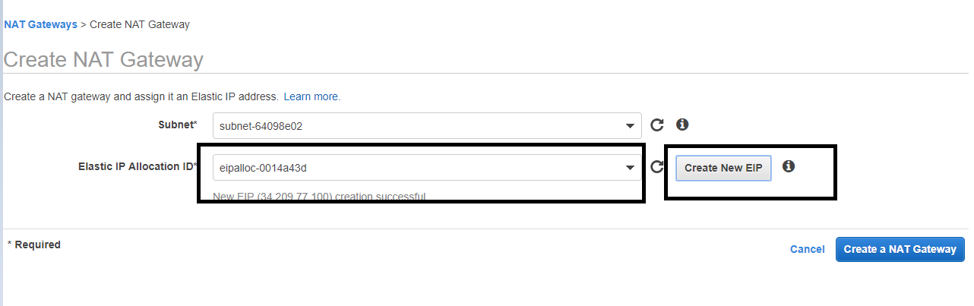

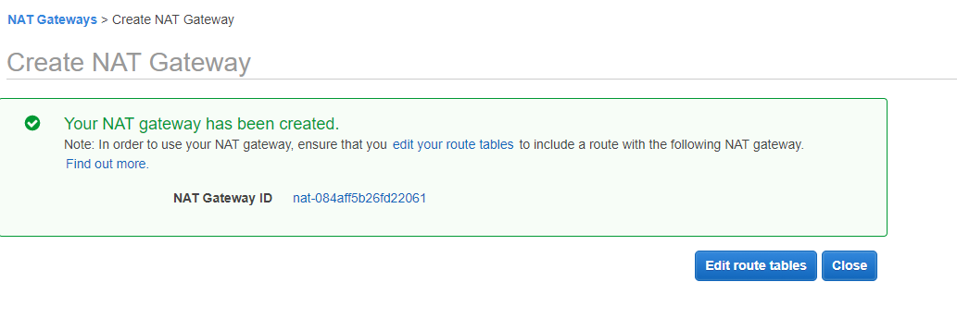

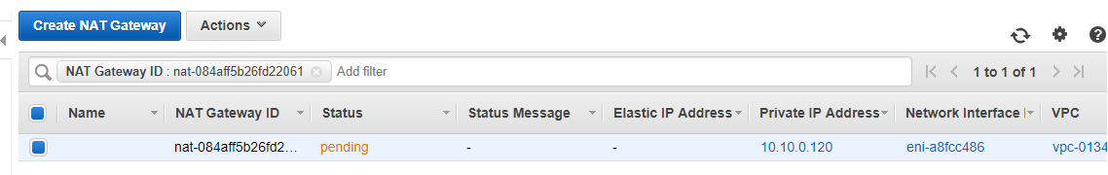
It takes time to launch, Please be patient.

Adding NAT gateway to private network to reach internet.
